IPTC DDTS Mona – Keyboard Interface Description
DDTS Mona I/O Interface
Connector Pinout
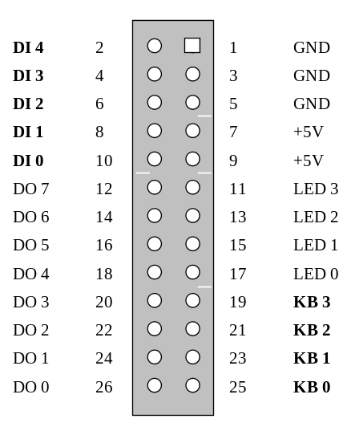

Internal Scan Codes

DI7 DI6 DI5 DI4 DI3
-------------------------
* 0 # D G KB0
7 8 9 C F KB1
4 5 6 B E KB2
1 2 3 A D KB3

Internal Scan Codes Mapped to DBC Key Codes

AXEMA Scan DBC Key DBC Key Code Crossconnected
Key Code Type hex dec Pins
-------------------------------------------------------
S1 * PRGFN 0x12 18 KB0 – DI7
S2 7 PRGFN 0x13 19 KB1 – DI7
S3 0 PRGFN 0x14 20 KB0 – DI6
S4 8 PRGFN 0x15 21 KB1 – DI6
S5 # PRGFN 0x16 22 KB0 – DI5
S6 9 FIXFN 0x0D Clear KB1 – DI5
B PRGFN 0x01 1 KB2 – DI4
C PRGFN 0x17 23 KB1 – DI4

Axema Keyboard Crossconnect Schematic Diagram

Axema Key Code
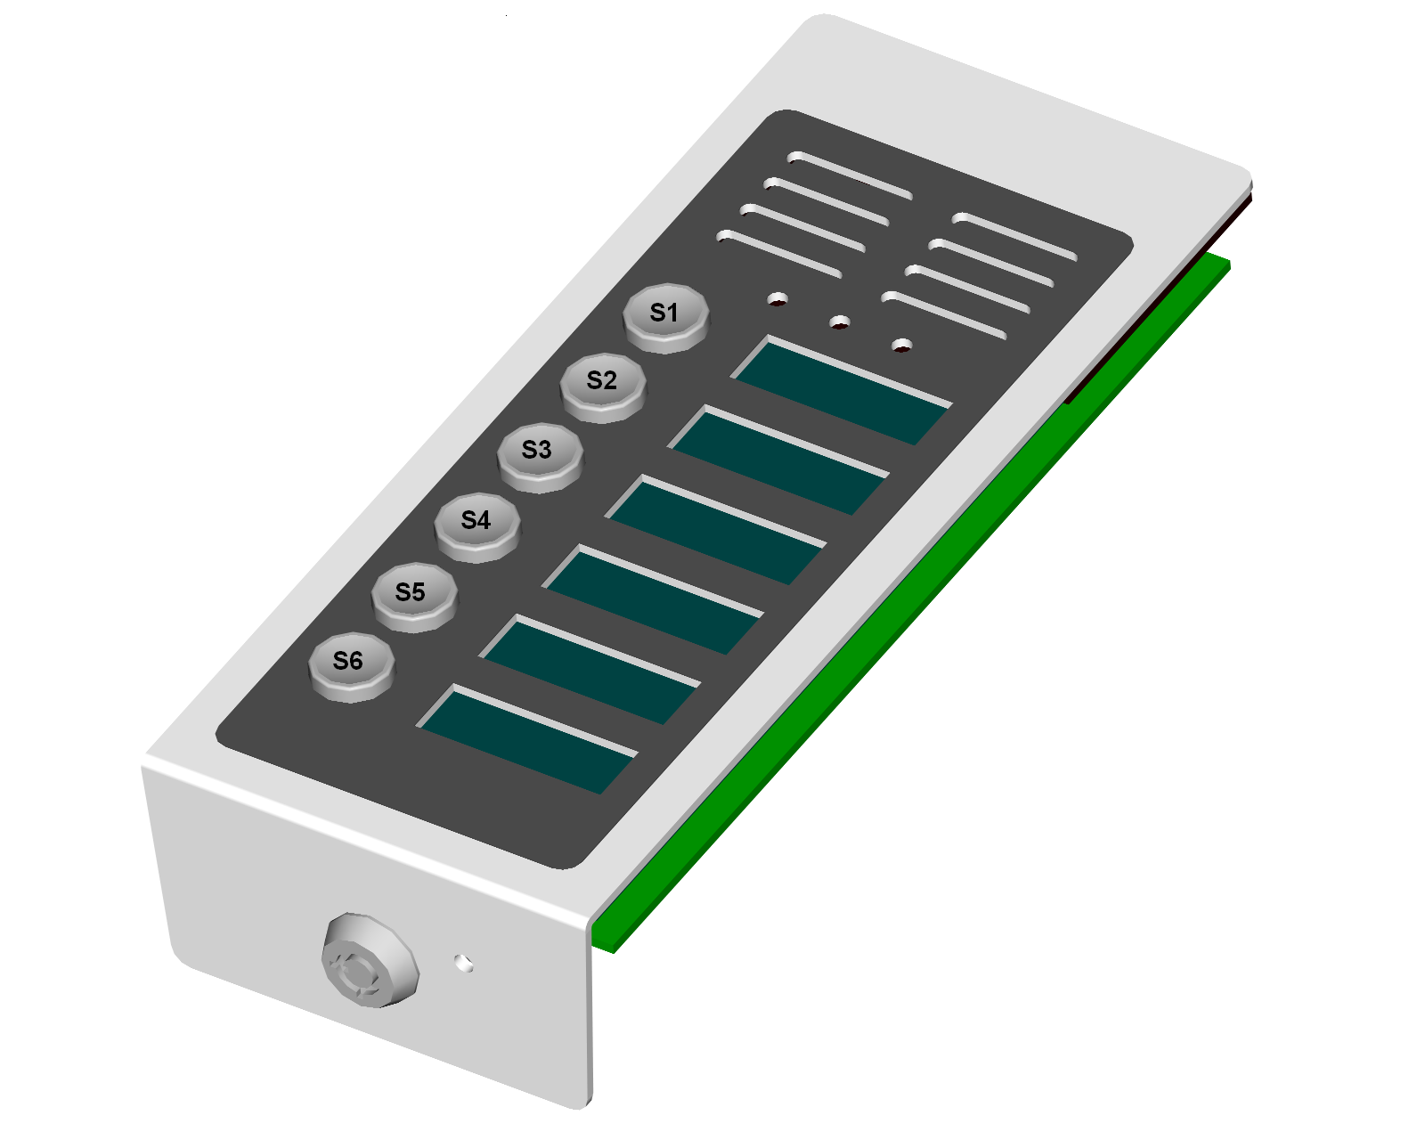
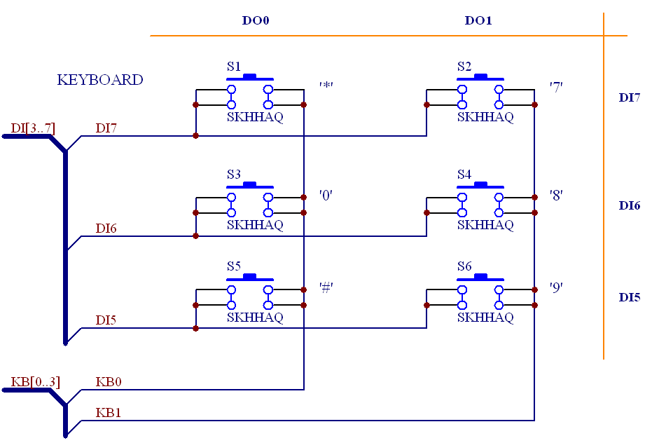
Internal
Scan Code
18
20
22
19
21
Clear
DBC Key
Code

DBC213 Keyboard Mapping

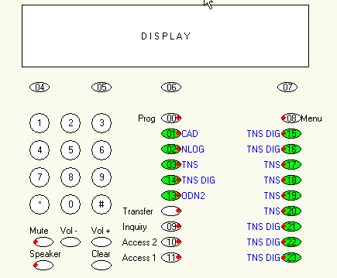
S1 (KB0-DI7)
S2 (KB1-DI7)
S3 (KB0-DI6)
S4 (KB1-DI6)
S5 (KB0-DI5)
(KB1-DI4)
KB2-DI4
S6 (KB1-DI5)

DBC Key DBC Key Code AXEMA Crossconnected
Type hex dec Key Pins
----------------------------------------------------
PRGFN 0x12 18 S1 KB0 – DI7
PRGFN 0x13 19 S2 KB1 – DI7
PRGFN 0x14 20 S3 KB0 – DI6
PRGFN 0x15 21 S4 KB1 – DI6
PRGFN 0x16 22 S5 KB0 – DI5
FIXFN 0x0D Clear S6 KB1 – DI5
PRGFN 0x01 1 KB2 – DI4
PRGFN 0x17 23 KB1 – DI4

